03-IAM (Global Service)

AWS can be accessed by 3 ways:
1)AWS Management Console (Protected by Password + MFA)
2)AWS CLI (Access key ID = Username; Secret access key = Password; Protected by access keys)
3)AWS SDK (Programmatic access; Protected by access keys)
Programmatic access means interacting with AWS services programmatically via code, scripts, or command-line tools using direct API calls, rather than manually clicking through the web-based AWS Management Console.
AWS CLI:
*Tool used to interact with AWS services using commands in your command-line shell.
*Direct access to the Public API's of AWS services.
*Develop scripts to manage your resources.

Access Key is created in the Security credentials Tab
Path: User(Go Inside)-->Security credentials Tab (Scroll Down; you can find over the option) -->Access Keys

AWS SDK:
*Enables you to access and manage AWS services programmatically.
*Language specific APIs (set of libraries).
*Embedded with your application. Ex: AWS CLI is built on AWS SDK for python.
*Supports JavaScript, Python....

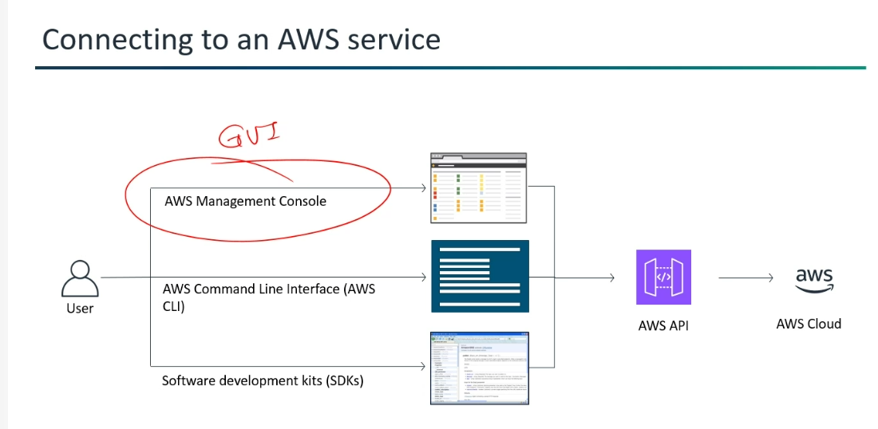

*Customers move to AWS, because of its "Increased Agility and Decreased Complexity and Risks".
The Amazon Web Services (AWS) environment is an integrated collection of hardware and software services
designed to provide quick and inexpensive use of resources. An API represents a way to communicate with a resource.
*Agility (Quick)--> Rapidly adapt to changes in the market, customer demands or the overall business environment.

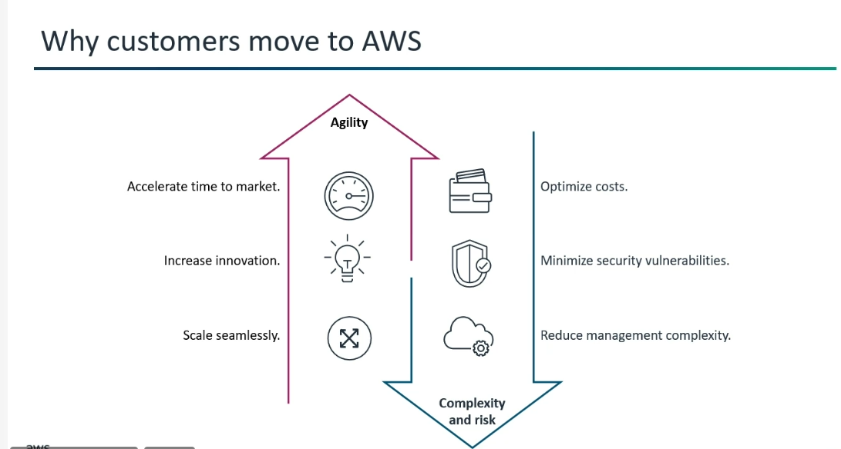
For SAA-03:
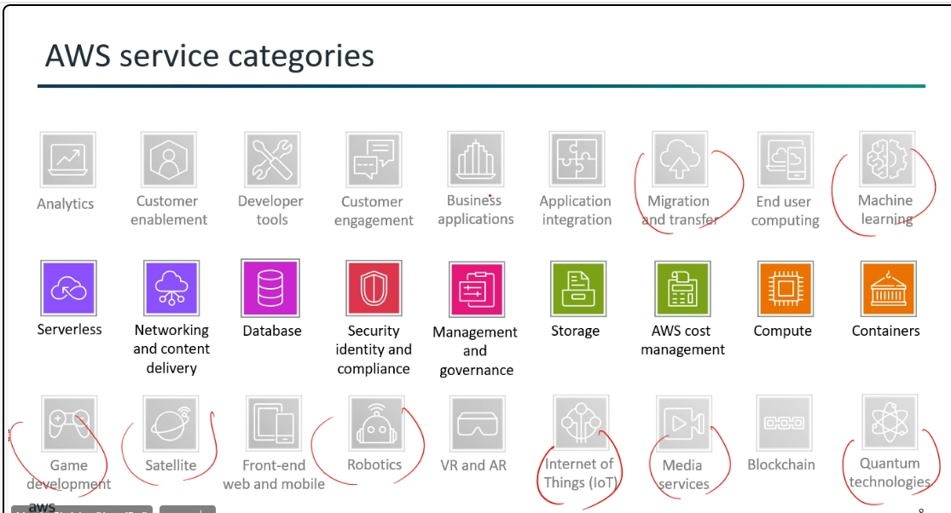

Root user:
*For One AWS account , there will be only "One Root User" and the root user have separate credentials( Email and password).
*Root user has the "Ultimate Authority". ( But, we cannot find the root user).
*Root user grants permission to the sub-users(IAM) what resources they can access and use.
*Even though the sub-user (IAM user) has the ability to create other sub-users (IAM users) and grants them full access, but still the root user is necessary to perform certain "Account-Level Critical Actions".
1)Closing the AWS Account.
2)Changing the AWS Support Plan.
3)Modifying root user contact information.
4)Accessing and modifying billing information for IAM users.
(this often requires explicit enabling for the IAM users by the root user).
5)Enabling or disabling certain security controls at the account level.
*Root user can't use IAM policy. The root can be restricted only by Service Control Policies (SCPs).
*Root user --> Not preferrable to do daily task.
*In One AWS account -->we can create "N" no.of environments
*Environment --> logical separation of AWS resources and configurations, designed to support different stages of application's development and deployment lifecycle.
(Different stages -->Dev, Prod and Test).
*For all 6 different environments, it is a strongly recommended and widely adopted best practice to create 6 separate AWS accounts.
This approach provides the highest level of isolation, security, and operational efficiency for your AWS resources across your different development stages.
IAM (Global Service):
Why should I use IAM?
*Identity and Access Management is a powerful tool for securely managing access to AWS services and resources.
(The name IAM itself define -->
Identity is that "Authentication" (Verifying the identity using credentials) + Access is that "Authorization" (determining what actions you are allowed to perform).
*Global Service --> Available across all regions.
*Using IAM, we can create and manage AWS users and groups and use permissions to allow and deny their access to AWS resources.
*Groups contain only users not other Groups.
*A user can belongs to "Multiple Groups".
*IAM Group has IAM USERS.
IAM Role has privileges.
IAM Policy has IAM Permissions
By default,
IAM Users (We can create up to 5,000 IAM users in your AWS account. )
IAM Group (Default: 300 IAM groups per region; Maximum quota: 500)
IAM Role (Default: 1,000 IAM roles per region; Maximum quota: 5000)
IAM Policy:
Customer managed policies per account(Default: 1500 per region; Maximum quota: 5000)
Managed policies per role (Default: 10 per region; Maximum quota:20)
Managed policies per user (Default: 10 per region; Maximum quota:20)
Managed policies per group(Default: 10 per region; Maximum quota:10)
(Note: These limits can be increased with a quota increase request).
*Logged-in IAM user appearing in the IAM Users list is simply a reflection of its existence as an identity within your AWS account.
*In essence, you're not just looking at a list of other users; you're looking at the complete list of all users.
*Deleting an IAM user from the IAM users list is how you delete that IAM user within your AWS account. There isn't a mirrored version of the IAM user tied directly to the root account in a way that would require a separate deletion. The root user is separate from the IAM users you create.

*Analogy: Looking at a Class Roster
Imagine you're a student in a classroom, and your teacher asks you to look at the class roster (the list of all students in the class).
* You are a student (an IAM user). You have your own unique name and seat in the class.
* The class roster is the IAM Users list. It's a comprehensive directory of everyone officially registered in that particular class.
When you look at the class roster, you'll naturally see your own name listed among all the other students. You're part of the class, so your name is on the class list.
*We should give only least privileges to IAM users. (Don't give more permissions than user needs)
*Granular Permission--> Specific permission -->It is called PoLP.
Non-Granular Permission--> Allows All permissions
* The Principle of Least Privilege (PoLP) is giving only the minimum set of permissions to the entity (such as a user, process, application, or system) for enhanced Security.
(If we give all permissions, it will cost you lot of money.)
AWS services and resources:
*AWS Services are the distinct products that AWS offers to its customers.
AWS Resources are the specific instances or entities that you create and manage within those AWS services.
For example:
* If you use the Amazon EC2 service, an EC2 instance is a resource.
* If you use the Amazon S3 service, an S3 bucket and the objects within it are resources.

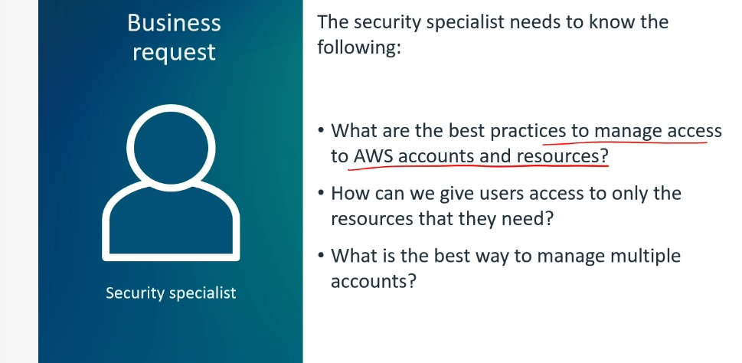

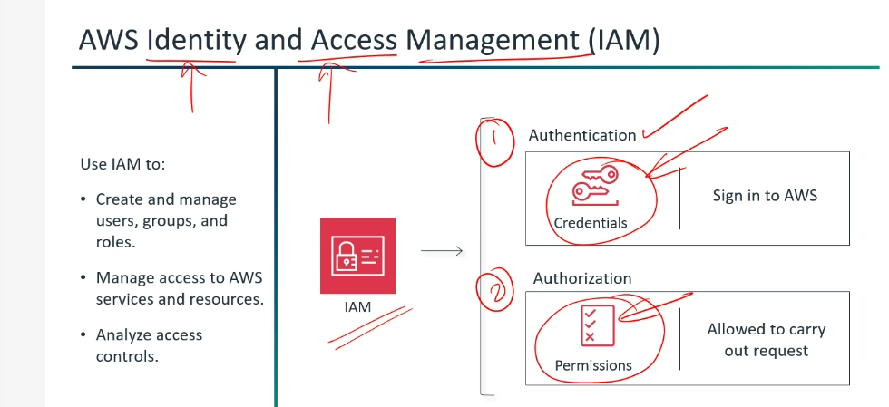

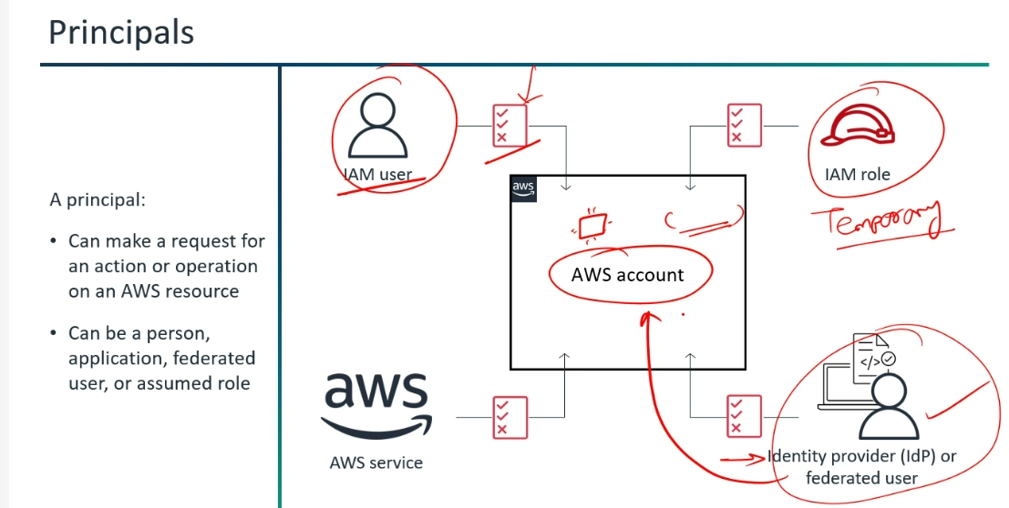

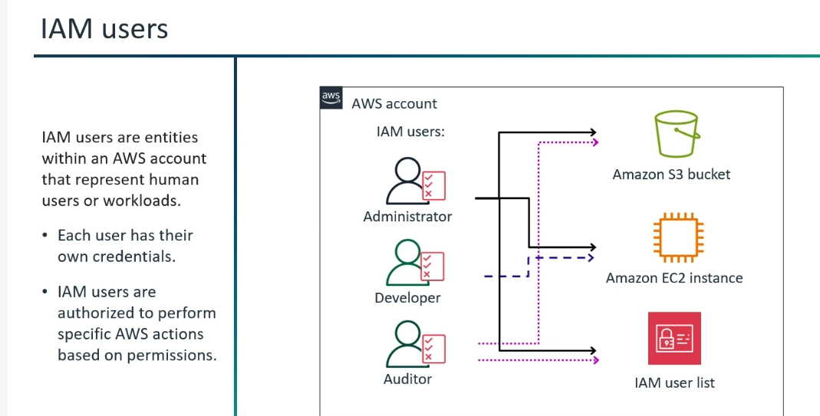

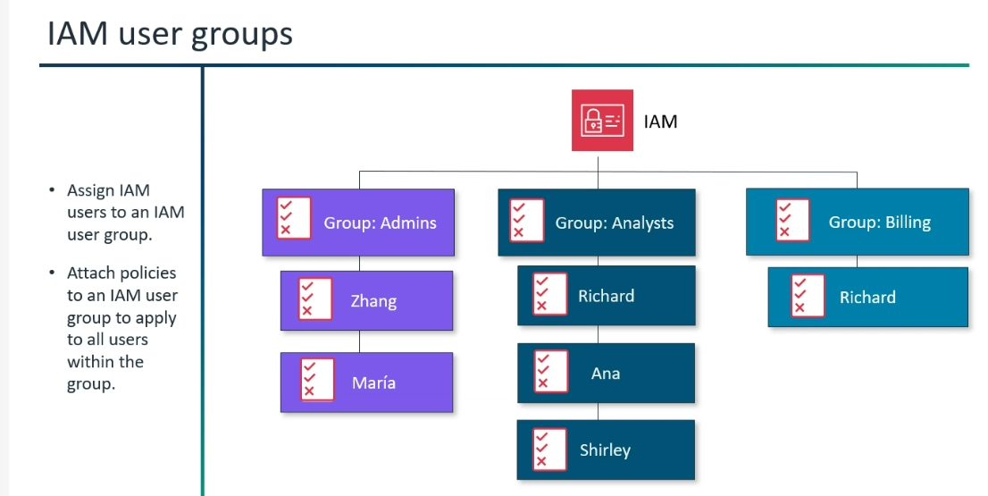

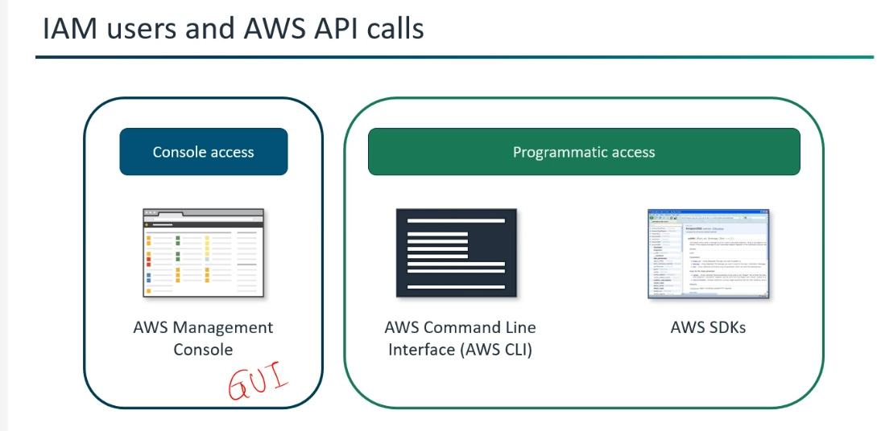
IAM Policy:
(Security Policies: How can we give users access only to only the resource the need? -->IAM Policy)
*An IAM policy is a collection of permissions, it defines what the identity can or cannot do in AWS.
*Predefined policy by AWS are there or if you want to create a policy , you can create your own customized policy.
*IAM Policy will be in "JSON" Format.
*JSON (JavaScript Object Notation)
Statement: Array of elements (Effect, Action, Resource)
Effect: Allow/Deny
Action: Get/Put Object
Resource: ARN(Amazon Resource Names)
*Version is not part of a statement.
*Ways to create IAM Policy ( in the following one of the methods).
1)AWS Management Console
2)AWC CLI
3)AWS API (Kind of Programming (JSON))
(API --> Application Program Interface provides programmatic access to manage users, groups, roles, permissions and policies within your AWS account.)
*Policies will be stored in S3 bucket.
*Policies attached directly to the user, group, or role --> Identity-based policies
Policies attached directly to the resource itself (e.g., an S3 bucket policy, an SQS queue policy).--> Resource-based policies
(The only difference in the code is, "Resource-based policies have "Principal" in their code whereas "Identity-based policies" does not.)
*If you are using, customer managed policy, you should know
1)Version
2)Effect
3)Action
4)Resources (Who needs to access)
5)Notation
*Inline Policy --> Type of permissions policy that is directly embedded into a single IAM identity (a user, group, or role).
AWS does not recommend "Inline Policy", it does not have reusable capabilities.
* AWS generally recommends using managed policies (especially customer-managed policies) for most use cases due to their reusability and easier management.
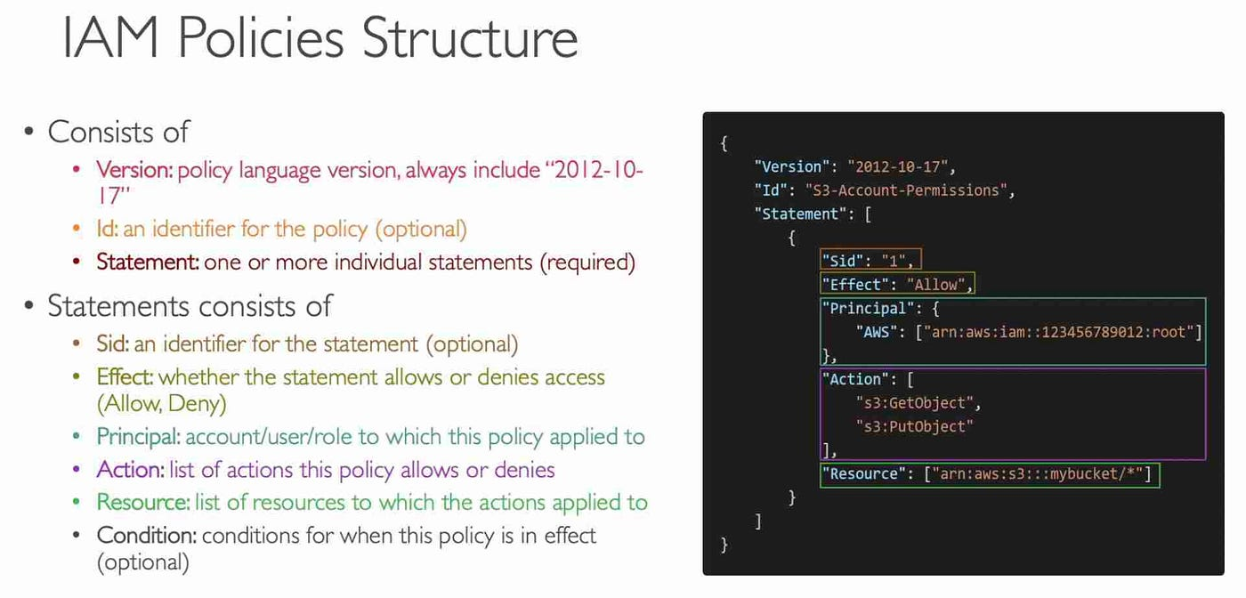

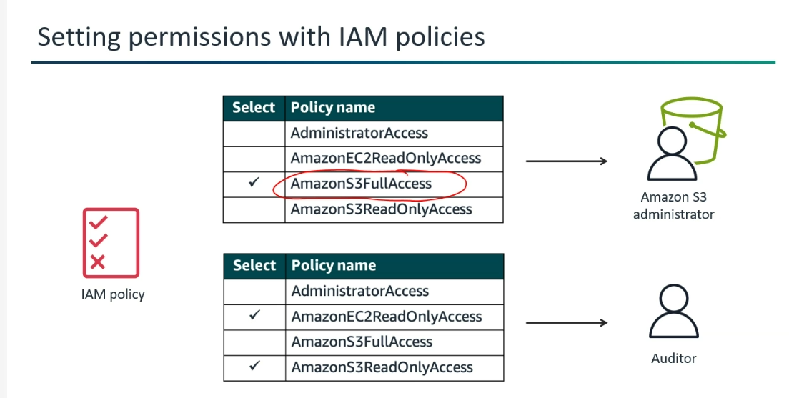

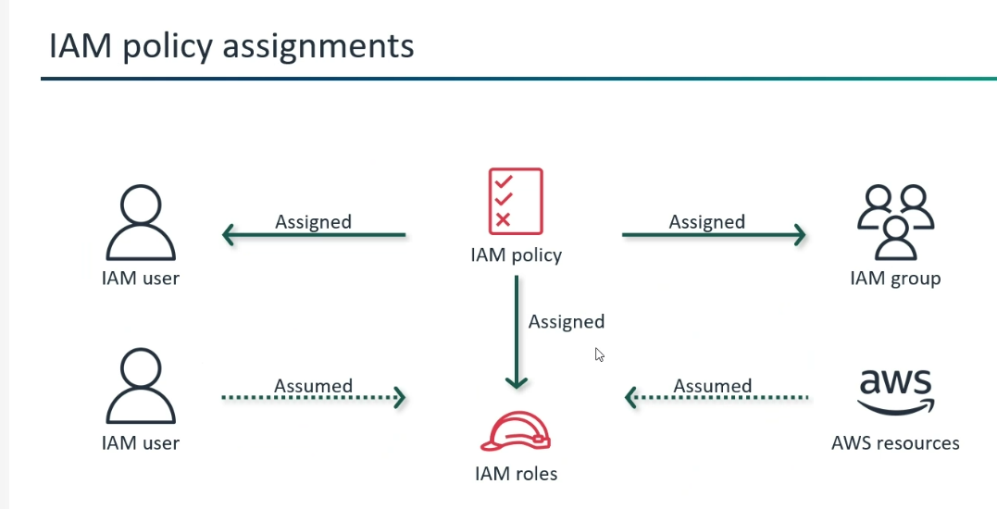

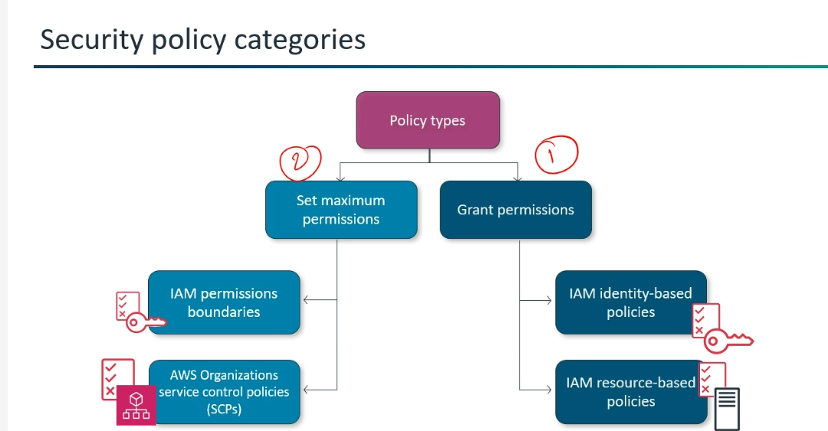

AWS security policy categories are split into two primary functional branches based on how they control access:
Grant Permissions
IAM identity-based policies: Inline or managed policies attached directly to users, groups, or roles to specify what actions they can perform.
IAM resource-based policies: Policies attached directly to a resource (like an S3 bucket or SQS queue) to specify who can access it and what actions they can perform.
Set Maximum Permissions
IAM permissions boundaries: Advanced policies that set the maximum permissions an identity-based policy can grant to an IAM entity.
AWS Organizations service control policies (SCPs): Policies that establish central control over the maximum available permissions for all accounts within an organization.

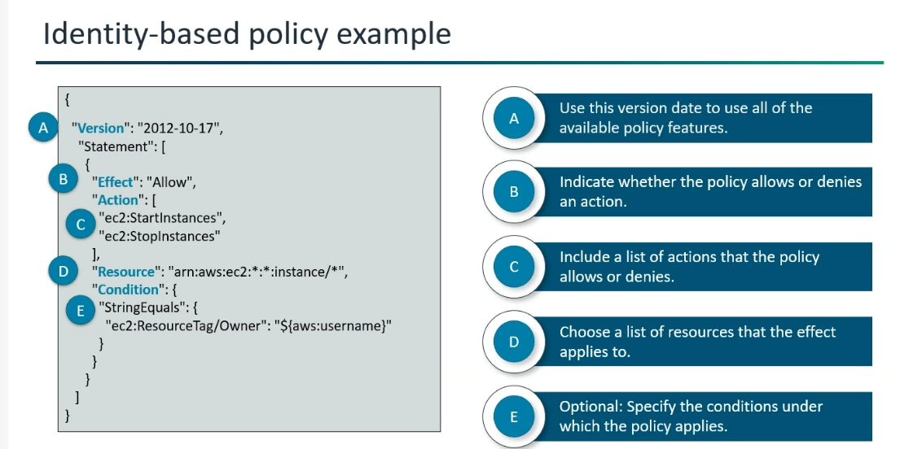
*Explicit deny is that "In code, they have mentioned not to allow the specified thing."
Implicit Deny is that "If in code they have specified only the particular thing to get "allowed (read only access EC2"
except that none other actions(accessing S3 bucket-->X) can be performed.
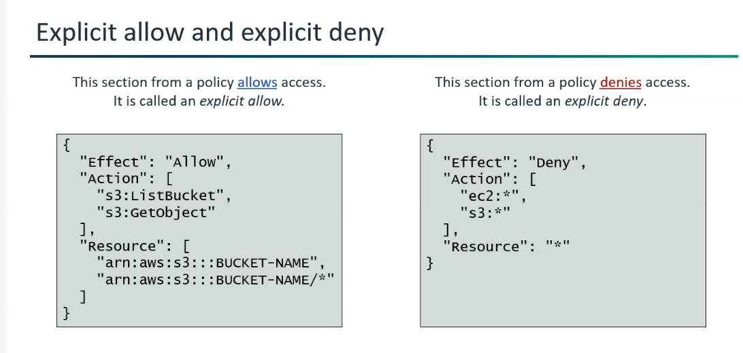

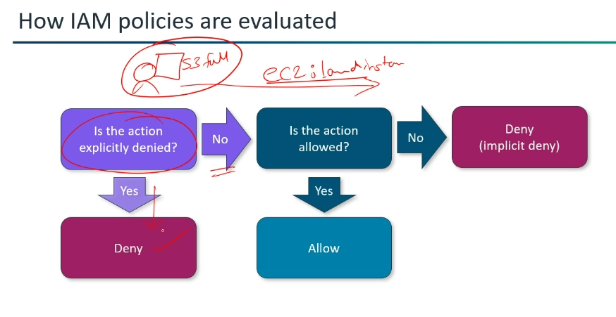

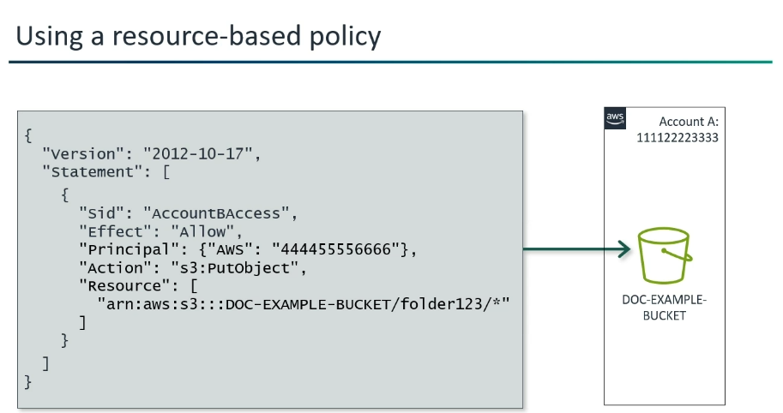

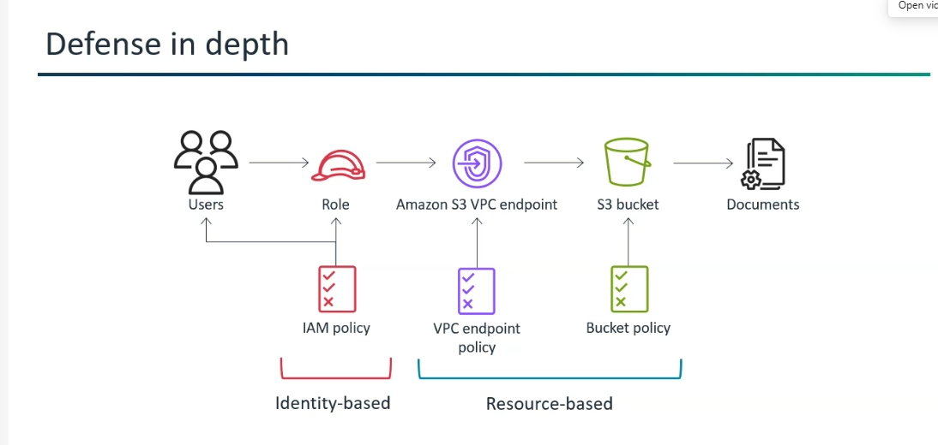
*IAM Permission boundary does not grant any permissions itself.
*Instead, it defines the maximum permissions that an IAM user or role can exercise ,
by "Limiting the user's permission which is already granted by IAM Identity-based policies".
Ex: If I am having admin role, I can assign admin role to the users who are working under me. But it limit that actions, in order to avoid the condition that "Even the person who are working under you can even delete your account, if there are admin".
*The effective permissions are the intersection of the identity-based policies and the permission boundary.
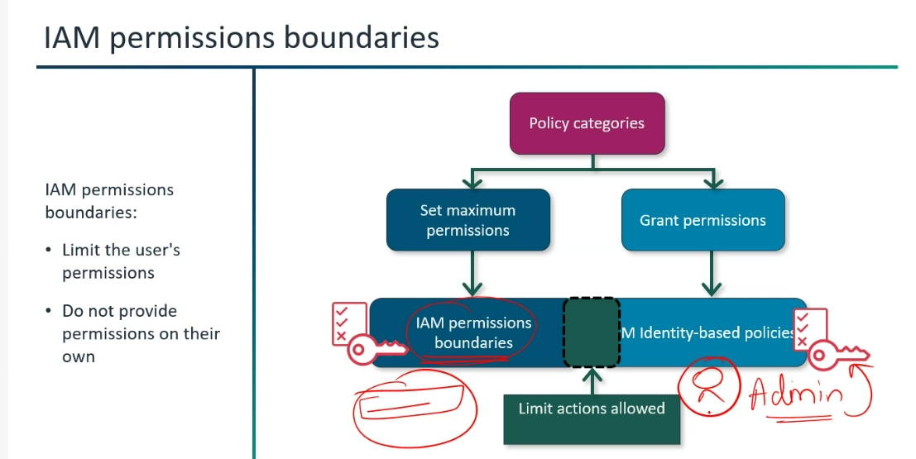

IAM Permissions Boundaries
Define maximum limits: They cap the maximum permissions that identity-based policies can grant to an IAM entity (user or role).
Do not grant access alone: They restrict permissions but cannot provide permissions on their own; the effective permissions are the intersection of the identity-based policy and the boundary.
Delegated administration: Commonly used to let developers create or manage their own users/roles safely without exceeding organizational security constraints
Managing Multiple Accounts:
* Structuring multiple AWS accounts under a single billing entity to centralize billing and maximize cost savings. It is called Consolidated Billing.
(*Aggregated usage of accounts-->Track the controls of Billing,…and Huge discount will be there.)
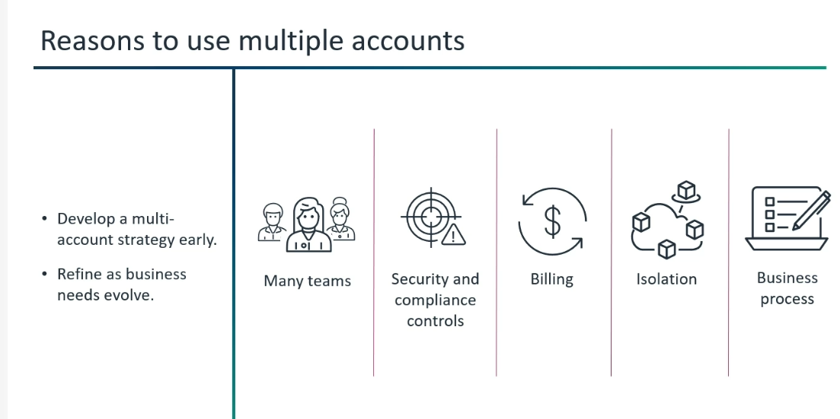

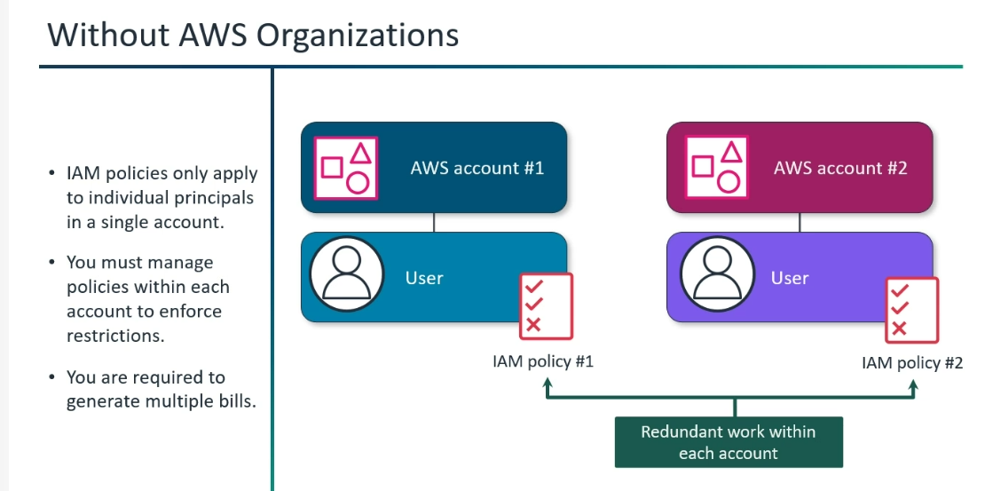
*PROD,DEV,TESTING-->All accounts are clubbed to form an Organization Unit.
*All the root accounts are clubbed to manage multiple accounts.
*If OU is in "Mumbai" region, the children accounts under this OU can be able to access "Only to Mumbai region".
*If SCP Policy -->Enable and attached to the OU level -->All the permissions are inherited to all the users within the children account.
Ex: If SCP, "Denys access to California" then all other OU and children accounts cannot access to "California".
*Service control policies (SCPs) are a type of organization policy that you can use to manage permissions in your organization.
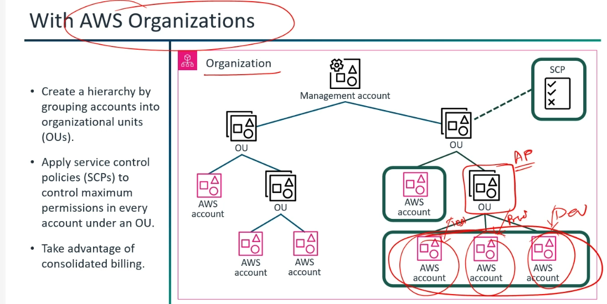
*SCP Policy --> SCP Policy restrict the maximum permissions that can be granted by IAM policies.
SCP do not grant permissions, they acts as a filter.

*Imagine a club with a security guard (SCP) and a bouncer (IAM Policy).
If the Security Guard (SCP) says "No one can enter the VIP lounge," then even if the Bouncer (IAM Policy) says "Sarah can dance in the VIP lounge," Sarah won't get in.
The SCP sets the ultimate limits.
The Security Guard (SCP) tells you what you cannot do, or only what you can do, at a high level.
The Bouncer (IAM Policy) tells you what you are allowed to do, but only if the Security Guard hasn't already shut it down.

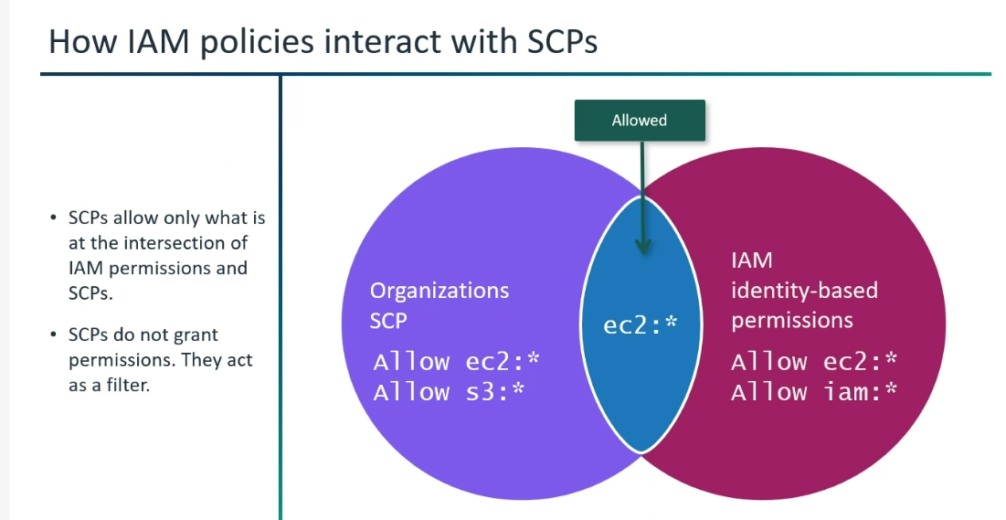

How IAM Policies Interact with SCPs
Intersection of Permissions: Effective access is limited strictly to what is allowed by both the Organizations Service Control Policy (SCP) and the IAM identity-based permissions.
Filter, Not Grant: SCPs do not grant permissions on their own; instead, they act as a security guardrail or filter that caps what IAM policies can do.
Example Evaluation: If an SCP allows ec2:* and s3:*, but the IAM policy allows ec2:* and iam:*, the final allowed permission is restricted only to the overlap (ec2:*).

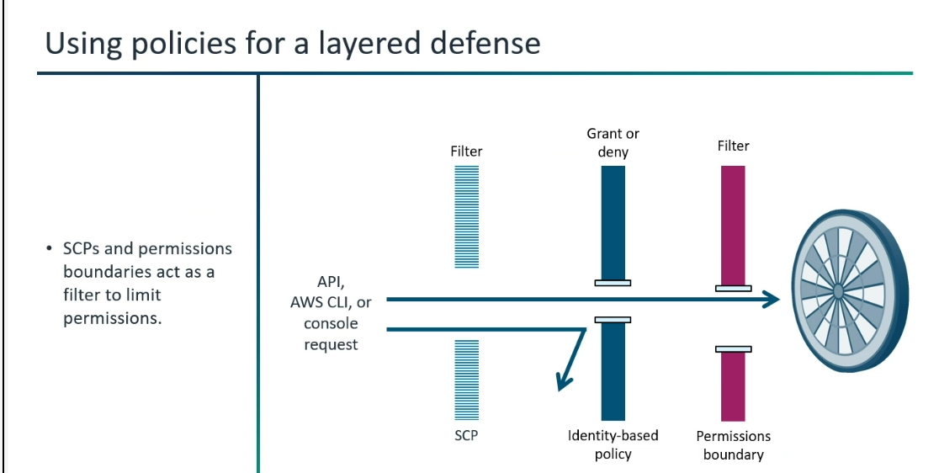

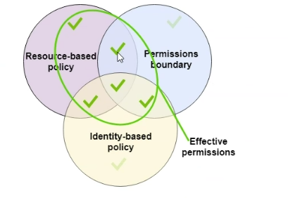

Effective Permissions Evaluation (Intersection of Policies)
Core Intersection: Effective permissions are determined by the overlap where multiple policy types intersect.
Evaluated Components: The diagram highlights the interaction between Resource-based policies, Identity-based policies, and Permissions boundaries.
Final Access: An action is only allowed if it passes through the combined guardrails and evaluation criteria of all applicable policies simultaneously.
IAM Role:
*IAM Role -1)It is not a set of permissions. X
It is a Trusted Entity, assuming the role.✓
*An IAM policy is a collection of permissions, it defines what the identity can or cannot do in AWS.
*IAM Role is what actions, the identity is allowed to do perform.
*In order to assume Role, the identity should be added in a "Trusted Policy".
*After assuming the role, only the role permissions are valid for the trusted entities not others (Policies).
*Roles do not have permanent credentials like passwords or access keys. When an entity assumes a role, AWS provides temporary security credentials.
*We can login as a "IAM Role Member" in AWS Account -->By assuming the role.
*IAM roles provide temporary credentials for federated access, cross-account/service access, and forwarding access sessions.
*IAM groups cannot assume the "IAM Role."
*IAM Session Duration: The minimum session duration is 1 hour, and can be set to a maximum of 12 hours.
*What is the importance of IAM Role?
AWS Identity and Access Management (IAM) roles are entities you create and assign specific permissions to that allow trusted identities such as workforce identities and applications to perform actions in AWS.
IAM is a critical cybersecurity function that organizes all sizes of privileged access management.
*Creating a role for service is also possible.
Ex: In EC2 -->Instances-->Check out the required instances-->Actions-->Modify IAM Role-->….
This service can call API calls. (API Call=Requests)
*IAM Role-->Authentication(Sign-in)+ Authorization (Permissions)
Authentication--> Trust-->Who can assume this role (Define by the role trust policy)
Authorization--> Permissions-->What you can do after assuming a role (Defined by IAM permission policies)
*One or more IAM policies are attached to the role, defining the permissions.
*IAM Role is useful for:
* AWS services (like EC2 instances or Lambda functions) to access other AWS resources.
* Federated users (users managed outside of AWS).
* Cross-account access (granting access to resources in another AWS account).

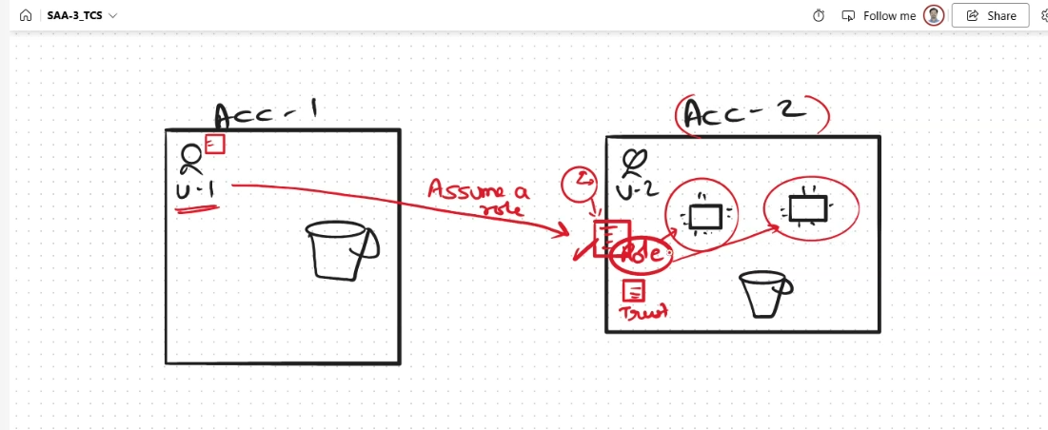

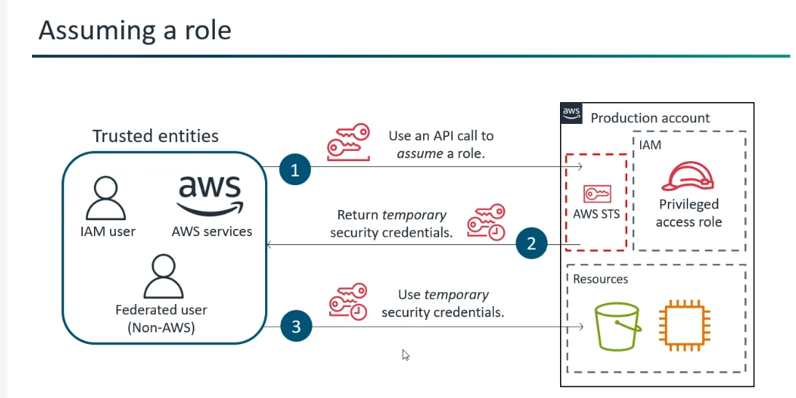

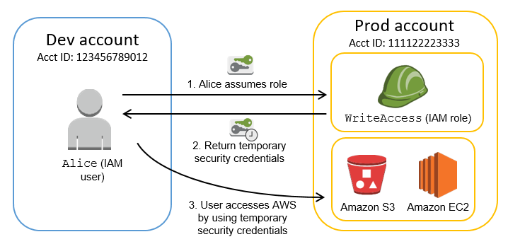

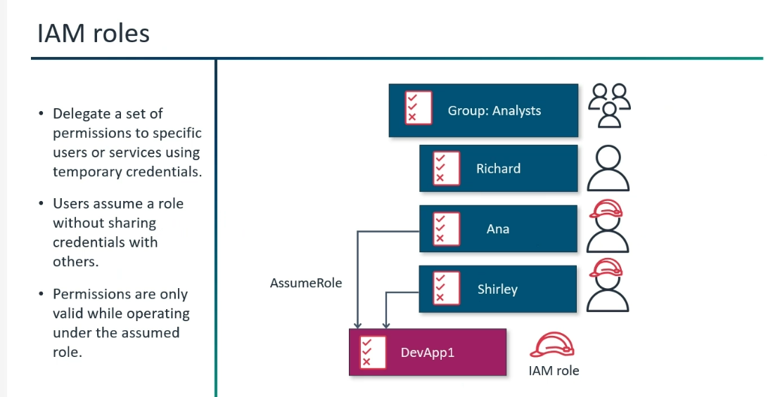
Authentication:
*2FA -->Two-Factor Authentication.
Requires two different types of verification factors to confirm your identity before granting access.
1)Password
2)Authenticator App or one-time code
*MFA: (2FA is a type of MFA)
MFA-->Multi-Factor Authentication(Extra Security to the account)
Requires two or more different types of verification factors to confirm your identity before granting access.
We are adding more layers of security.
1)Password
2)Authenticator App or one-time code
3)Fingerprint Recognition
4)Face Recognition
5)Iris Recognition
Security Tools:
AWS Credentials Report (Account-level)
Path: IAM Dashboard--> Access Analyzer --> AWS Credentials Report
A report that lists all your account's users and the status of their various credentials.

Access Advisor ;Now the name changed to "Last Accessed" ()
Path: User(Go Inside)--> Last Accessed Tab.
Access advisor shows the service permission granted to a user and when those services are last accessed.
You can use this information to revise their policies.
Others:
*IAM Identity Center (Formerly known as AWS SSO (Single Sign-On) --> To manage multiple users from multiple accounts
in AWS.
(Central Gatekeeper for your AWS Environment).
It allows you to connect your existing workforce directory (like Okta, Azure AD, or Microsoft Active Directory) or create users directly in IAM Identity Center.
*IAM Access Analyzer helps you manage and control who can access your AWS resources.
It identifies resources shared with external entities, validates IAM policies, and helps you implement least privilege permissions.
🔑 1. Why Root Account Should NEVER Be Used for Daily Tasks

When you create an AWS account, the Root user is the single identity that has complete, unrestricted access to every resource and billing detail in that account. Think of it as the "Master Key" to your entire digital kingdom. Here is why you must lock it away and use IAM users or roles instead.

⚠️ Risk 1 — Unrestricted Permissions (Cannot Be Limited)
  - The Root user cannot be limited by any IAM policy — it bypasses all restrictions.
  - If a bad actor gains access, they can:
  - Delete all backups and S3 buckets
  - Change billing information and payment methods
  - Spin up massive GPU instances for crypto-mining — leading to huge unexpected bills
  - Close the AWS account entirely — permanently and irreversibly

⚠️ Risk 2 — Zero Granular Control (Root is "all or nothing" )
  - IAM operates on the Principle of Least Privilege.
  - With IAM you can give a developer access to only one specific S3 bucket, or allow a Cloud Engineer to manage only EC2.
  - Root is "all or nothing" — you cannot give someone "limited Root access." It does not exist.

⚠️ Risk 3 — Broken Audit Trail
  - CloudTrail logs will simply show "Root performed the action" — no individual accountability.
  - You lose the ability to track who did what, when, and why.
  - IAM users provide a clear audit trail linked to specific individuals.

⚠️ Risk 4 — Recovery Credentials at Risk
  - Root is your only way back into the account if all IAM admin users are locked out.
  - If Root is compromised or the password is forgotten from frequent use, regaining control requires AWS support + legal verification — a massive hurdle.

✅ Recommended Best Practices
# | Action | Why
1 | Create a strong, unique password for Root | First line of defence
2 | Enable MFA immediately — hardware security key preferred | Blocks credential theft
3 | Create an IAM Admin User for daily tasks | Limits blast radius
4 | Delete Root Access Keys (Access Key ID + Secret) | Prevents programmatic abuse
5 | Use Root ONLY for billing / closing the account | Minimises exposure

💡 Exam Tip: The SAA exam asks: "Which tasks REQUIRE Root?" — changing support plan, closing the account, enabling MFA on Root, and restoring IAM access when all admins are locked out.

🚧 2. Permission Boundaries

🎯 One-Line Answer: A Permissions Boundary is a managed policy used to set the maximum available permissions an IAM entity (user or role) can ever have, regardless of what its identity-based policies allow.

🔑 Core Concept
⚠️ Warning: Even if a user has AdministratorAccess ("Keys to the Kingdom"), if their Permissions Boundary says they can only touch S3 — they will ONLY be able to touch S3. Period.

  - For an action to be allowed, it must be granted by BOTH:
  - The Identity-based policy — what they can do
  - The Permissions Boundary — the maximum they are allowed to do
ℹ️ Note: Rule of Intersection: If an action is in the policy but NOT in the boundary → it is Denied.

🏗️ Real-World Example — Junior Cloud Engineer
  - You hire a Junior Cloud Engineer. You want them to manage S3 but NOT accidentally delete your production RDS database.

Layer | Policy | Grants
Identity-Based Policy | AdministratorAccess | Everything — S3, EC2, RDS, IAM...
Permissions Boundary | Allow s3:* only | S3 actions only
Effective Permission | Intersection of both | S3 only — RDS actions blocked

📜 The JSON Logic
Identity Policy (The "Yes" List):
{ "Effect": "Allow", "Action": "*", "Resource": "*" }

Permissions Boundary (The "Allowed Zone"):
{ "Effect": "Allow", "Action": "s3:*", "Resource": "*" }

ℹ️ Note: Outcome: The user can only perform S3 actions. Any attempt to use EC2 or IAM will be denied because it is not in the "Allowed Zone" of the boundary.

💡 Exam Tip: Permission Boundaries do NOT grant permissions — they only LIMIT them. You still need an identity-based policy that actually allows the action.

🏷️ 3. ABAC — Attribute-Based Access Control

🎯 One-Line Answer: Permissions are assigned based on matching attributes (tags) between the user and the resource — if tags match, access is granted automatically.

⚙️ How It Works
  - You create a single policy that says: "Allow access if the user's Project tag matches the resource's Project tag."
  - No policy updates needed when new projects are created — just tag resources correctly.

👨‍💻 The Pro-Tip Interview Example
  - Developer tagged Department: Finance → automatically gets access to any EC2 instance tagged Department: Finance.
  - No IAM policy editing required — access is automatic.
  - Developer moves to Project: Beta → change their tag → they instantly lose Alpha access and gain Beta access.
  - Zero IAM policy changes ever needed.

💡 Exam Tip: ABAC is the best practice for scaling in AWS because it reduces "policy bloat" and administrative overhead.

👥 4. RBAC — Role-Based Access Control

🎯 One-Line Answer: Access is granted based on who you are (your role / job function) within the organisation — permissions are assigned to predefined job functions, not individuals.

🏗️ Real-World Example — Finance Team
  - Create a single IAM Group called Finance-Reporting-Role.
  - Attach a policy: allows only s3:Get and s3:List on the "Invoices" bucket.
  - New accountant Anjali joins → add her to the group → she immediately inherits all permissions.
  - She moves to Marketing → remove her from Finance group → all Finance access revoked instantly.

✅ Why Interviewers Value RBAC
Benefit | Explanation
Simplicity | Easy to understand "Who is in which group"
Security | Prevents Permission Creep — manage the group policy, not 50 individual policies
Compliance | Faster auditing — clear group membership during security reviews
AWS Defaults | Most AWS Managed Policies (ReadOnlyAccess etc.) are built for RBAC

⚖️ 5. ABAC vs RBAC — Which Is Better?

ℹ️ Note: RBAC is the industry standard for simplicity. ABAC is the best practice for scaling. Most mature companies use a Hybrid model.

📊 Head-to-Head Comparison
Feature | RBAC | ABAC
Key Question | "What is your job title?" | "Do your tags match the resource tags?"
Best For | Static, small teams | Dynamic, rapidly scaling environments
Effort | Manual (update groups/roles) | Automatic (update tags)
Policy Count | Grows with roles (Role Explosion) | One policy scales infinitely
AWS Managed Policies | Built for RBAC | Requires tagging discipline
Audit Clarity | Very clear group membership | Tag-based, needs tag governance

💥 The "Role Explosion" Problem — Why ABAC Was Born
  - 100 projects → 100 IAM Roles in RBAC → management nightmare.
  - ABAC Fix: Create one Developer-Role. Permissions change dynamically based on tags.
  - Start Project-D tomorrow → just tag the new server → no IAM code changes ever.

🎓 The Senior Engineer Interview Answer
"While RBAC is the industry standard for its simplicity and clear audit trails, it often leads to Role Explosion at scale. Modern cloud architectures are shifting toward ABAC (or a Hybrid model) to allow permissions to scale dynamically using resource tags without needing to create hundreds of individual IAM policies."

💡 Exam Tip: If asked "Why not just stick with RBAC?" — mention Role Explosion and explain the ABAC tag-matching approach.

🌐 6. On-Premises Server Accessing S3 — IAM Roles Anywhere

🎯 One-Line Answer: IAM Roles Anywhere is the most secure method — it eliminates long-lived access keys by using X.509 certificates to provide temporary, short-lived AWS credentials to on-premises servers.

🤔 Why Not Just Use Access Keys?
Method | Risk | Recommended?
Long-lived Access Keys | If leaked, attacker has permanent access until manually rotated | No
IAM User credentials | Static, hard to rotate at scale, no expiry | No
IAM Roles Anywhere | Uses X.509 certs, issues temporary credentials, auto-expires | Yes

💡 Exam Tip: Any time the exam mentions on-premises workloads needing AWS access, think IAM Roles Anywhere for temporary credentials or STS AssumeRole via a federation setup.

⚡ 7. Policy Conflict: Identity-Based Deny vs Resource-Based Allow

🎯 One-Line Answer: The outcome is Denied — an explicit Deny in any policy, whether identity-based, resource-based, or an SCP, always overrides any Allow.

📜 The 3 Golden Rules of AWS Policy Evaluation
Priority | Rule | Outcome
1st | Explicit Deny found anywhere in the chain | Immediately Denied — no exceptions
2nd | No Deny AND no Allow found | Implicitly Denied (default)
3rd | Explicit Allow found AND zero Deny statements | Allowed

🏗️ Real-World Example
  - Bucket Policy (Resource-based): Explicitly says "Allow access to this Engineer."
  - IAM User Policy (Identity-based): Explicitly says "Deny access to S3" (security lockdown).
  - Result: Even though the bucket "wants" to let them in — the Deny is the final word.

📊 Decision Matrix
Policy A | Policy B | Final Outcome | Rule Applied
Allow | Allow | Allowed | Simple permission
Allow | Deny | Denied | Explicit Deny overrides all
None | None | Denied | Implicit Deny (default)
Allow | (Not mentioned) | Allowed | Explicit Allow

⚠️ Warning: A single "No" (Deny) always beats a thousand "Yes" (Allows). This is absolute in AWS.

🔀 8. VPC Endpoint Restriction — aws:SourceVpce

🎯 One-Line Answer: The aws:SourceVpce condition key is used in resource-based policies (like S3 Bucket Policies) to create a network perimeter, ensuring data can only be accessed through a specific, authorised VPC Endpoint.

🏗️ Real-World Example — Financial Data Lockdown
  - Create an Interface VPC Endpoint for S3.
  - Add a condition to the S3 bucket policy:
"StringEquals": { "aws:SourceVpce": "vpce-1a2b3c4d" }
  - Result: Data is "locked" inside your network — inaccessible from the home internet even with valid credentials.

⚖️ SourceVpc vs SourceVpce
Condition Key | Restricts To | Granularity
aws:SourceVpc | Specific VPC ID | Any endpoint in that VPC
aws:SourceVpce | Specific VPC Endpoint ID | Most granular — specific endpoint only

💡 Exam Tip: aws:SourceVpce is more granular than aws:SourceVpc. Use SourceVpce when you want to restrict to one specific endpoint, not just any endpoint in the VPC.

📋 9. Multiple Statement Blocks in an IAM Policy

🎯 One-Line Answer: Multiple Statement blocks in a policy are logically OR-ed together — any Allow results in access, unless an explicit Deny exists anywhere.

🤔 Why OR Logic?
  - Statement 1: Allows access to S3 Bucket A.
  - Statement 2: Allows access to S3 Bucket B.
  - Result: User can access both A and B — they do not need to satisfy both rules simultaneously (AND logic would be impossible).

⚠️ The Deny Exception
  - Even though statements are OR-ed for Allows — Explicit Deny is still the ultimate authority.
  - Statement 1: Allow S3 → Statement 2: Deny S3 → User is Denied.

🪤 The Sid (Statement ID) Trap
Concept | Does it affect evaluation? | Purpose
Statement Order | No — AWS evaluates all statements simultaneously | Does not matter
Sid (Statement ID) | No — zero effect on policy processing | Documentation only

💡 Exam Tip: Interviewers love asking if statement order matters. It does NOT. All statements are evaluated simultaneously.

🔗 10. Service Role vs Service-Linked Role

🎯 One-Line Answer: Service-Linked Roles are predefined by AWS and linked to a specific service. Standard Service Roles are user-defined and fully customisable.

📊 Comparison
Feature | Standard Service Role | Service-Linked Role
Created by | You | AWS (automatically)
Customisable? | Yes — full control | Predefined by AWS, limited editing
Trust Policy | You define who can assume it | AWS service defines it
Example | EC2 role to upload logs to S3 | AWSServiceRoleForAutoScaling
Deletion | You can delete any time | Cannot delete while service uses it

🏗️ Real-World Examples
  - Standard Service Role: You create a role for an EC2 instance to upload logs to a specific S3 bucket. You decide the exact bucket it can access.
  - Service-Linked Role: When you set up an Auto Scaling Group, AWS creates AWSServiceRoleForAutoScaling automatically — allowing Auto Scaling to talk to EC2 and ELB to add/remove instances. You do not manage this.

💡 Exam Tip: Service-Linked Roles ensure the AWS service always has exactly the permissions it needs — no more, no less. You cannot accidentally break the service by editing them.

⚙️ 11. AWS Config — Access Key Rotation Enforcement

🎯 One-Line Answer: AWS Config with the access-keys-rotated managed rule detects IAM users with access keys older than a defined threshold, flagging them as non-compliant automatically.

⚡ Automated Remediation Flow
Step | Action | Service
1 | Config rule evaluates all access key ages | AWS Config
2 | Non-compliant keys flagged (e.g., older than 90 days) | AWS Config
3 | Config Remediation triggers automatically | AWS Config + SSM
4 | SSM Automation document disables the non-compliant key | AWS Systems Manager
5 | Security team notified via SNS or Security Hub | SNS / Security Hub

💡 Exam Tip: "I would link the AWS Config rule to an SSM Automation document. This allows AWS to automatically disable the key as soon as it's flagged, ensuring compliance without manual intervention."

🌍 12. Cross-Region Lambda + DynamoDB Access

🎯 One-Line Answer: Because IAM is a global service, a standard IAM Role created in any region can be assumed by a Lambda function to access resources in any other region — just specify the cross-region ARN in the policy.

✅ Why a Standard IAM Role Is Sufficient
  - IAM roles do not "live" in a region — they are global.
  - The Lambda side: attach the role to the Lambda function.
  - The policy side: grant dynamodb:GetItem, dynamodb:PutItem etc.
  - The resource side: specify the ARN of the DynamoDB table in the other region:
arn:aws:dynamodb:us-east-1:123456789012:table/MyTable

🪤 Common Traps in This Question
Wrong Assumption | Why It Is Wrong
"You need a Cross-Region Role" | There is no such thing. All IAM roles work across regions.
"You need VPC Peering" | IAM + DynamoDB use the AWS public API — no private network pipe needed.
"Use Resource-based policy on DynamoDB" | DynamoDB does NOT support resource-based policies. Must use identity-based IAM role.

💡 Exam Tip: DynamoDB does not support resource-based policies. Always use an IAM role (identity-based policy) to grant Lambda access to DynamoDB.

🪟 13. Session Policies

🎯 One-Line Answer: A session policy creates a permissions boundary for a temporary session — the resulting access is the logical intersection of the identity-based policy and the session policy. If both do not allow it, it is denied.

⚙️ The "Filter" Logic
  - Identity Policy (The "Full" List): Everything the user/role could do — e.g., Full S3 + EC2 access.
  - Session Policy (The "Temporary Filter"): What is allowed just for this specific session — e.g., only S3 Read.
  - Result: User can only perform actions present in BOTH policies.
⚠️ Warning: Even if your main IAM User policy has AdministratorAccess — if your Session Policy only allows s3:ListBucket, you are blocked from everything else for the duration of that session.
🏗️ Real-World Example — The "Safe" Automation Script
  - You are a Systems Engineer (Administrator) with full account access.
  - You write a Python script to audit S3 buckets.
  - Risk: If the script has a bug, it might accidentally delete a production RDS database.
  - Solution: When calling AssumeRole, pass a Session Policy allowing only s3:Get* and s3:List*.
  - Outcome: Even though your main role is Admin, the script's session is sandboxed. Deleting RDS is physically impossible.

📊 Identity Policy vs Session Policy Matrix
Identity Policy | Session Policy | Final Outcome
Allow | Allow | Allowed
Allow | (Not mentioned) | Denied (Implicit)
Allow or Deny | Deny | Denied (Explicit)

💡 Exam Tip: Session policies are used with AssumeRole or federation(கூட்டமைப்பு)to temporarily narrow a user's permissions — the safety sandbox pattern.

🧱 14. Policies vs Roles — The Relationship

ℹ️ Note: Key mental model: Policies define PERMISSION (what can be done). Roles define IDENTITY (who can act).

🔗 Does a Role Consist of a Policy?
  - Yes. An IAM Role is a container for permissions — a role by itself has no power.
  - It requires Permissions Policies (JSON documents) attached to it to define allowed actions.
  - Additionally, a Role contains a Trust Policy — defines who/what can "assume" that role (a specific user, AWS service, or external identity).

🔗 Does a Policy Consist of a Role?
  - No. A policy is an independent, reusable object.
  - One policy can be attached to multiple users, groups, or roles.
  - A policy does not "contain" a role — it is attached to a role to grant capabilities.

🔗 Can You Attach a Policy Directly to an AWS Service?
  - Technically no. You cannot "glue" an IAM Policy directly onto an EC2 instance or Lambda function.
  - Instead, you use a Service Role as the bridge:
  - Create an IAM Role → attach a permissions policy → attach the role to the service

📊 Summary of Relationships
Question | Answer | Example
Does Role contain Policy? | Yes — policies are attached to roles | EC2 role with S3 policy attached
Does Policy contain Role? | No — policy is independent | One S3 policy attached to 10 roles
Attach policy directly to service? | No — use a Service Role as bridge | Lambda → IAM Role → DynamoDB policy
What is a Trust Policy? | Defines who can assume the role | Trust: ec2.amazonaws.com

💡 Exam Tip: Think of it as: Policy = permission slip. Role = identity card with permission slips attached. Services borrow the identity card (assume the role) to get permissions.

🔐 AWS STS (Security Token Service)
AWS STS (Security Token Service) issues temporary security credentials (Access Key ID + Secret Access Key + Session Token) when a role is assumed via AssumeRole, AssumeRoleWithSAML, or AssumeRoleWithWebIdentity.
STS — Security Token Service
  - Issues temporary credentials — Access Key + Secret + Session Token
API Call | Use Case
AssumeRole | Switch to another role / cross-account access
AssumeRoleWithSAML | SAML 2.0 federation (corporate identity)
AssumeRoleWithWebIdentity | Web identity (Google, Facebook, Amazon Cognito)
GetSessionToken | MFA-protected operations

👤 Cognito User & Identity Pools
Cognito User Pools authenticates Google users (handles the OAuth flow). Cognito Identity Pools then issues temporary AWS credentials so the authenticated user can access their S3 folder. This is the standard mobile app pattern — User Pools = authentication, Identity Pools = AWS access
⚙️ AWS Config & SSM Automation
AWS Config's access-keys-rotated managed rule detects non-compliant keys (older than threshold). Linking a Config Remediation to an SSM Automation document automatically disables the non-compliant key — no manual intervention needed.
🔀 Session Policies & Effective Access
Session policies create a temporary permission filter. Effective access = intersection of identity-based policy AND session policy. Since the session policy only allows s3:GetObject, s3:PutObject is not in the allowed set — it is implicitly denied even though the identity policy allows it. Session policies NARROW permissions for that session only.
🌐 Cross-Account S3 Access
For cross-account access to S3, BOTH policies must allow the action:
  - Account B's S3 bucket policy must allow the Account A user, AND
  - Account A's IAM policy must allow the S3 action.
If the user's identity-based policy in Account A doesn't allow S3, the access is denied — even if the bucket policy explicitly allows it.

An IAM policy evaluation involves: (1) No SCP restrictions, (2) An identity-based policy that allows s3:PutObject, (3) A resource-based policy on the S3 bucket that has an explicit DENY for the user's IP range, (4) A VPC endpoint policy that allows all S3 actions. The user makes the request from within the restricted IP range. What is the result?
Hard
A) Allowed — identity-based policy and VPC endpoint policy both allow it
B) Allowed — VPC endpoint policy overrides the bucket policy DENY
C) Denied — the explicit DENY in the bucket resource-based policy overrides all ALLOWs
D) Allowed — resource-based policies cannot DENY individual users
✅ Answer: C
This is a full policy evaluation chain: No SCP deny ✅ → Identity policy ALLOWs ✅ → Resource-based policy has explicit DENY ❌ → STOP. The explicit DENY in the bucket policy wins immediately. VPC endpoint policies do not override explicit DENYs — they are evaluated as additional filters. An explicit DENY anywhere in the evaluation chain is always final. The bucket DENY based on IP range blocks the request completely.
A Security audit finds that an IAM role has sts:AssumeRole with Resource: "*" and no Condition. What is the risk, and what should be done?
Hard
A) No risk — sts:AssumeRole requires console access to use
B) Risk of privilege escalation — the role can assume any role in any account; restrict with specific ARNs and add ExternalId condition for cross-account
C) No risk — AssumeRole is always audited by CloudTrail
D) Minor risk — only aA Seffects same-account roles
✅ Answer: B
sts:AssumeRole with Resource:"*" means this identity can attempt to assume ANY role in ANY AWS account — a significant privilege escalation risk. Fix: (1) Restrict Resource to specific role ARNs, (2) For cross-account assumptions, add a Condition with sts:ExternalId to prevent the Confused Deputy problem, (3) Ensure CloudTrail is logging all STS API calls.
A junior IAM admin has been given a role with iam:CreateRole and iam:AttachRolePolicy. They also have a Permissions Boundary applied that only allows S3 and EC2. Can this admin create a new role with AdministratorAccess and use it to bypass the boundary?
Hard
A) Yes — they can create a role with AdministratorAccess and assume it to get full access
B) No — the new role they create would also be subject to the same Permissions Boundary
C) Yes — iam:CreateRole allows bypassing all boundaries
D) No — iam:CreateRole is blocked by the S3/EC2-only permissions boundary
✅ Answer: D
The admin's own Permissions Boundary only allows S3 and EC2 actions. Since iam:CreateRole is NOT in the boundary's allowed actions, the admin cannot call iam:CreateRole at all — the boundary blocks it. Even if they could create a role, best practice mandates requiring iam:CreateRole to also pass a boundary (using iam:PassRole with boundary conditions) to prevent privilege escalation. The boundary protects against this attack vector.
IAM policy has three Statement blocks. Statement 1 allows S3, Statement 2 allows EC2, Statement 3 allows RDS. The same policy also has Statement 4 that denies EC2. What is the effective access?
Medium
A) S3, EC2, and RDS — all three ALLOW statements win
B) S3 and RDS only — the EC2 DENY overrides the EC2 ALLOW
C) Nothing — one DENY in any statement denies all access
D) EC2 only — the last statement wins
✅ Answer: B
Multiple statements are OR-ed for ALLOWs — so S3 and RDS are allowed. However, the explicit DENY on EC2 overrides the ALLOW on EC2. Statement order does not matter. All statements are evaluated simultaneously. Result: S3 ✅, RDS ✅, EC2 ❌.
A company uses Microsoft Active Directory on-premises. They want employees to log in to the AWS Console using their existing AD credentials without creating IAM users. What should be configured?
Medium
A) Cognito User Pools with AD sync
B) SAML 2.0 federation with AWS STS AssumeRoleWithSAML
C) Web Identity Federation with Google as IdP
D) Create IAM users matching each AD user manually
✅ Answer: B
SAML 2.0 federation allows corporate AD users to authenticate via their IdP and receive a SAML assertion, which STS exchanges for temporary AWS credentials via AssumeRoleWithSAML. No IAM users need to be created for each employee.
What is the default access level for a new IAM user who has no policies attached?
Easy
A) Full access to all AWS services
B) Read-only access to all services
C) No access — denied by default (implicit deny)
D) Access to the AWS Console only
✅ Answer: C
IAM follows "default deny" — a new user with no policies has zero access to any AWS service. Access must be explicitly granted via attached policies. This is the Principle of Least Privilege in action.
Q3. A security team wants junior admins to create IAM roles but only roles that cannot exceed a certain set of permissions. What feature should be used?
  - A) IAM Groups
  - B) Service Control Policies
  - C) Permission Boundaries
  - D) Resource-based policies
Answer: C | Permission Boundaries define maximum permissions a role can have, enabling safe delegation of IAM admin.

The One-Line Memory Rule

▎ SCP = restricts the account
▎ Permission Boundary = restricts an individual role/user

Whenever the exam says "delegate IAM role creation safely" or "junior admins creating roles" → always Permission Boundary.

📌 Quick Reference Cheat Sheet — IAM Deep Dive

Topic | One-Line to Remember
Root Account | Master Key — lock it. Enable MFA. Delete access keys. Use IAM Admin User.
Permission Boundary | Sets MAX permissions. Effective = intersection of policy AND boundary.
ABAC | Tags match → access granted. Best for scaling. No policy updates needed.
RBAC | Job function = access. Simple. Leads to Role Explosion at scale.
Explicit Deny | One Deny beats all Allows — always, everywhere, no exceptions.
aws:SourceVpce | Locks S3 access to a specific VPC Endpoint ID — most granular.
Statement Blocks | OR-ed together. Order does not matter. Sid is documentation only.
Service-Linked Role | AWS creates it. Predefined. Cannot delete while service uses it.
AWS Config | Detects non-compliant access keys. SSM Automation auto-disables them.
Cross-Region IAM | IAM is global. Specify cross-region ARN in policy. No special role needed.
Session Policy | Temporary permission filter. Intersection of identity + session policy.
Roles vs Policies | Role = identity. Policy = permission. Service needs Role as bridge.
DynamoDB + IAM | DynamoDB has NO resource-based policies. Must use identity-based IAM role.
IAM Roles Anywhere | X.509 certs → temporary credentials for on-prem. No long-lived keys.

Master these concepts and you will handle any IAM question in the SAA-C03 exam or interview with confidence.

AWS Identity and Access Management (IAM)
Advanced Practice Quiz & Explanations
Comprehensive Scenario-Based Assessment with Detailed Explanations
Q1. A company has an S3 bucket policy that DENIES access to all principals unless the request comes from a specific VPC endpoint. An IAM user in the same account has an identity-based policy that explicitly ALLOWS s3:GetObject on that bucket, and the user is accessing via the internet (not the VPC endpoint). What is the result?
○ Access is allowed because IAM Allow overrides bucket policy Deny
✔ Access is denied because an explicit Deny in any applicable policy always wins
○ Access is allowed because S3 bucket policies only apply to cross-account access
○ Access is denied only if MFA is not present
Explanation: In the AWS policy evaluation logic, an explicit Deny in ANY policy (identity-based, resource-based, SCP, permissions boundary) always overrides any Allow. The condition on the VPC endpoint isn't met, so the explicit Deny fires regardless of the IAM Allow.

Q2. You attach a permissions boundary to an IAM role that allows only 'ec2:*' actions. The role's identity-based policy grants 'ec2:*' and 's3:*'. What actions can the role actually perform?
○ ec2:* and s3:*, since identity policy is the final authority
✔ Only ec2:*, since permissions boundaries cap the maximum permissions regardless of identity policy
○ Neither, because boundary and identity policy mismatch causes implicit deny on everything
○ Only s3:*, since permissions only restrict EC2-related services
Explanation: A permissions boundary sets the maximum permissions an identity-based policy can grant. Effective permissions = intersection of identity policy and boundary. Since the boundary only allows ec2:*, s3:* is blocked even though the identity policy allows it.

Q3. A cross-account role (Account B) is assumed by users in Account A via sts:AssumeRole. The trust policy on the role in Account B specifies Account A as principal, but does NOT include a condition requiring MFA. Account A's IAM policy allows sts:AssumeRole only if MFA is present. What happens when a user in Account A without MFA tries to assume the role?
○ The assumption succeeds because the trust policy is the only thing evaluated for cross-account AssumeRole
✔ The assumption fails because IAM policy in the calling account also must permit the action, and its MFA condition isn't satisfied
○ The assumption fails because MFA conditions only apply to console logins, not AssumeRole calls
○ The assumption fails because cross-account roles always require MFA by default
Explanation: Both the trust policy (resource-based, in Account B) AND the calling principal's identity policy (in Account A) must allow the AssumeRole call. Since Account A's policy requires MFA via a condition and the user has none, the call is denied — the trust policy alone isn't sufficient.

Q4. An organization uses AWS Organizations with an SCP attached at the OU level that denies 'iam:CreateUser' for all accounts in that OU. An account admin in one of those accounts has an IAM policy with 'iam:*' Allow and is the root user of that account. Can the root user create an IAM user?
○ Yes, root user permissions bypass all SCPs
✔ No, SCPs apply to all principals in the account including the root user, and an explicit Deny cannot be overridden
○ Yes, but only if the root user has MFA enabled
○ No, but only because IAM users require a separate CloudTrail approval workflow
Explanation: SCPs apply to every principal in member accounts, including the root user. SCPs set boundaries — they never grant permissions themselves — and an explicit Deny in an SCP cannot be overridden by any identity policy, even root's own full-access permissions.

Q5. You need to grant a Lambda function in Account A temporary access to write objects into an S3 bucket in Account B. Which combination is correct and follows least privilege?
○ Attach a bucket policy in Account B granting the Lambda's execution role access, and no changes needed in Account A
✔ Give the Lambda's execution role an identity-based policy allowing s3:PutObject on the Account B bucket, AND add a bucket policy in Account B granting that role access
○ Create a new IAM user in Account B and hardcode its access keys as Lambda environment variables
○ Enable S3 cross-account replication instead of a policy since IAM cannot grant cross-account object writes
Explanation: Cross-account resource access via IAM roles requires permission on BOTH sides: the identity-based policy on the calling role (Account A) must allow the action, and the resource-based policy (bucket policy in Account B) must also grant access to that specific role ARN. Hardcoded keys violate least privilege and rotation best practices.

Q6. A user has two IAM policies attached: Policy 1 allows 's3:*' on 'arn:aws:s3:::finance-bucket/*'. Policy 2 explicitly denies 's3:DeleteObject' on 'arn:aws:s3:::finance-bucket/*' but only when the request does not come from IP range 10.0.0.0/8. The user makes a DeleteObject request from IP 203.0.113.5 (not in that range). What is the outcome?
○ Allowed, because Policy 1's broad Allow takes precedence for wildcard actions
✔ Denied, because the condition in the Deny policy (source IP not in 10.0.0.0/8) is met, triggering the explicit Deny
○ Allowed, because explicit Denies with conditions are evaluated last and ignored if a broader Allow exists
○ Denied, but only because DeleteObject always requires MFA regardless of policy
Explanation: The Deny's condition (NotIpAddress 10.0.0.0/8) evaluates to true since 203.0.113.5 is outside that range, so the explicit Deny is triggered. Explicit Deny always overrides Allow when its conditions are satisfied, regardless of how broad the Allow is.

Q7. Which statement about IAM Identity Center (formerly AWS SSO) permission sets vs. traditional IAM roles in a multi-account AWS Organizations setup is TRUE?
○ Permission sets are just IAM policies stored in the management account and directly attached to users in each member account
✔ Permission sets are templates that IAM Identity Center provisions as IAM roles in each target account, and updates propagate to those roles when the permission set changes
○ Permission sets replace the need for IAM roles entirely; no roles are created in member accounts
○ Permission sets can only grant AWS-managed policies, never customer-managed or inline policies
Explanation: IAM Identity Center provisions permission sets as actual IAM roles (with a specific naming pattern) in each assigned member account. When you edit a permission set, IAM Identity Center pushes the updated policy to all the provisioned roles across accounts automatically.

Q8. A company wants EC2 instances to access DynamoDB without embedding credentials. They also want the same instances to be able to assume a role in a partner's AWS account for a specific batch job that runs a few times a day. What's the correct architecture?
○ Store the partner account's access keys in Systems Manager Parameter Store and retrieve them at runtime
✔ Attach an instance profile with a role that has DynamoDB permissions AND sts:AssumeRole permission for the partner role ARN; the partner's role trust policy allows this account/role as principal
○ Create two separate instance profiles and switch between them using EC2 metadata rewrites
○ Use IAM Identity Center permission sets on the EC2 instance since it supports cross-account federation natively for EC2
Explanation: A single instance profile role can have permissions for DynamoDB directly AND permission to call sts:AssumeRole for the partner's role. The partner's role trust policy must list this account (or specific role ARN) as a trusted principal. This avoids storing any long-term credentials.

Q9. An IAM policy has a Resource element using a variable: 'arn:aws:s3:::company-bucket/${aws:username}/*' with Action 's3:GetObject' and 's3:PutObject'. What does this pattern achieve, and what's a critical prerequisite for it to work as intended?
✔ It restricts users to their own 'folder' (prefix) in the bucket; it requires the IAM username to exactly match the prefix structure already present in the bucket, and works only for IAM users (not roles, since aws:username is not populated for role sessions)
○ It automatically creates a new folder for every new IAM user the first time they log in
○ It grants access to all folders whose name is alphabetically before the username
○ It requires the bucket to have versioning enabled or the variable will not resolve
Explanation: This is the classic IAM policy variable pattern for user-isolated S3 prefixes: aws:username only resolves for IAM users, not for federated/role sessions (which would need userid or a session tag-based variable like aws:PrincipalTag instead). The folder must already conceptually match the username in the key naming scheme; IAM doesn't create S3 'folders'.

Q10. A security team wants to ensure that even if an IAM user's long-term access keys are leaked, an attacker cannot call iam:CreateAccessKey to mint additional keys for that same user or any other user, but the user should still be able to manage their own MFA devices. What's the best approach?
○ Delete all access keys company-wide and rely only on the AWS Console with passwords
✔ Attach a permissions boundary to every user that explicitly denies iam:CreateAccessKey and iam:CreateUser, while a separate identity policy allows self-service MFA actions scoped with aws:username conditions
○ Enable GuardDuty, which automatically blocks CreateAccessKey calls from leaked credentials
○ Rely on CloudTrail alerts alone, since IAM has no way to preemptively block an action for a specific principal type
Explanation: A permissions boundary can set a hard ceiling that denies privilege-escalation actions like iam:CreateAccessKey, closing off a common self-privilege-escalation path. Combining this with a scoped self-service MFA policy (using aws:username in the resource ARN) lets users manage only their own MFA devices. GuardDuty detects, it doesn't preemptively block API calls.

Cloudshell:(Terminal)
*Shell- Shell is the program that interprets and executes the commands that you type into the CLI.
It acts as the intermediary between you and the operating system's kernel.
*Cloudshell- It is a command line interface that helps to interact with your "cloud resources" without needing to install any command-line tools (Bash, PowerShell or Z shell) locally.
*There is no additional charge for using AWS Cloudshell.
*CloudShell is not present in other regions and so you can install AWS Command Line Interface (CLI), a separate tool that you need to install on your local machine.
*You can run up to 10 shells at the same time in each AWS Region for your account.
*In AWS CloudShell, each user gets 1 GB of persistent storage per AWS Region.
So, while Google Cloud Shell offers 5 GB of persistent storage.
*If you stop using AWS CloudShell for 120 days , unless you take action, your data is automatically deleted from the persistent storage of that Region. You can prevent removal by launching AWS CloudShell again in that AWS Region.
*Persistent -->lasting for a long time
* Persistent storage, also known as non-volatile storage, is a type of data storage that keeps data even when the power is turned off.
*Persistent storage is located in your home directory ($HOME) and is private to you.
Command Line Interface (CLI)--> Package needs to be install and then can control via Command Prompt.
*Interface - Place for interaction between the two separate entities to interact with each other.
*Text-based interaction will be there, we can type commands over here.
*Unified tool to manage your AWS Services .With just one tool to download and configure, you
can control multiple AWS Services from the command line and automate them through scripts.
*Unified tool --> Single application or Platform.
*Terminal--> Text based User Interface (As Cloudshell is also "Text based user Interface",
we are calling "Cloudshell" is a "Terminal").
Shell-->Interpreter
There are many types of interfaces are there Text based User Interface, Graphical User Interface, Voice user Interface.
Q&A:
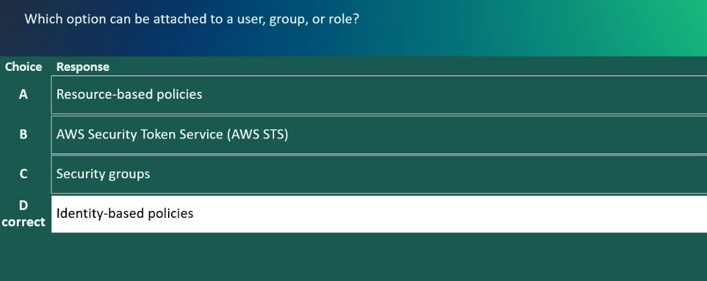

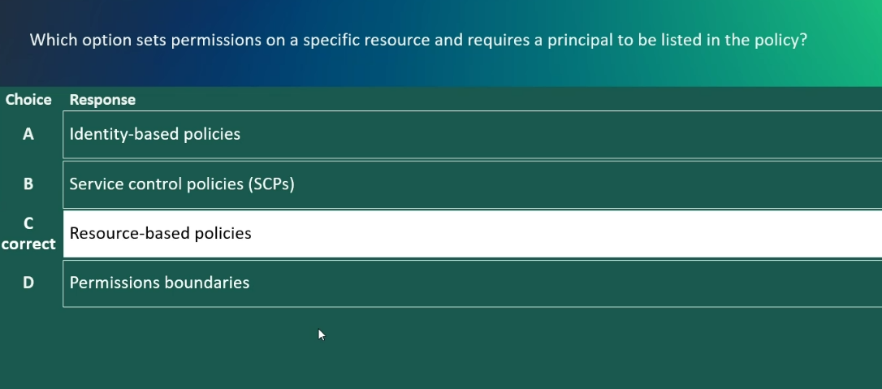

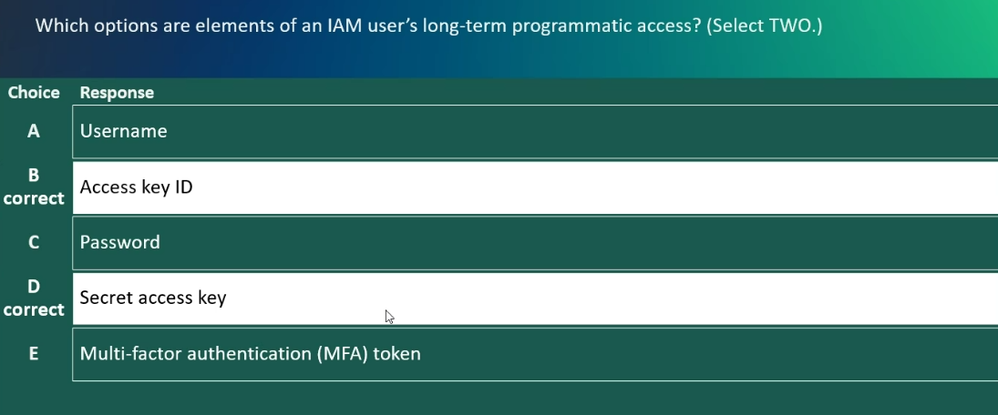

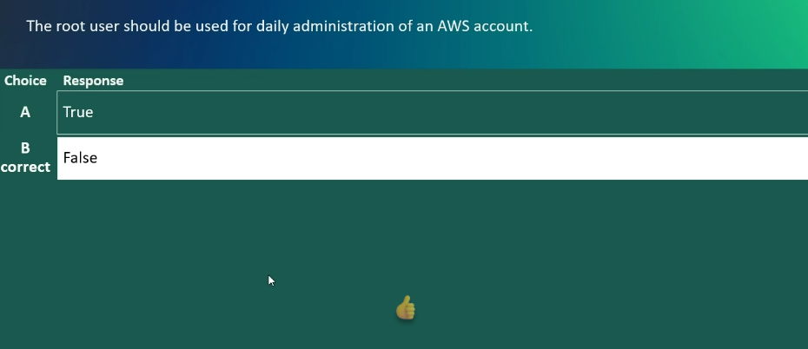
Tips:
* Privileges = Permissions (what you're allowed to do)
* Entity = User, Group, or Role (who or what can have permissions)
*Federation: a group of organizations, countries, regions.

